**KATHMANDU UNIVERSITY**

**SCHOOL OF ENGINEERING**

**DEPARTMENT OF MECHANICAL ENGINEERING**

FINAL REPORT OF THE PROJECT



FABRICATION OF SIMPLIFIED IMPULSE TURBINE

AMAN TAMANG

NISHAR VAIDHYA

RITIK RIMAL

SHRAYESH SHRESTHA

2020

**PROJECT EVALUATION**

FABRICATION OF SIMPLIFIED IMPULSE TURBINE

BY

Aman Tamang, Ritik Rimal, Nishar Vaidhya,Shrayesh Shrestha

This is to certify that I have examined the above project and have found that it is complete and satisfactory in all respects, and that any revisions required by the project examination committee have been made.

_______________________________________

NISCHAL POKHAREL

COORDINATOR

___________________________________________

PAWAN KARKI

SUPERVISOR

# ACKNOWLEDGEMENT

First of all we are very pleased to have conducted the project on “**FABRICATION OF SIMPLIFIED IMPULSE TURBINE”.** We would like to thank the Department of Mechanical Engineering, KU and the project supervisors and instructors to have provided us the opportunity to work on this project and also to have assisted us in the working process.

We are also very grateful to the Technical Training Center and all the instructors and specialists present there who have not just provided but also assisted and directed us in using the tools and equipment present there.

# ABSTRACT

The development of turbines has been a long process since the past. Engineers are working on developing turbines that will have a greater efficiency and need a lesser effort every time.

The major objective of this project is to fabricate a Turgo turbine using the most basic components as a part of our basic studies. Due to lack of technical knowledge the turbine may not be able to generate the expected outcome but it will generate a small amount of electricity. Therefore this project has been conducted with the primary aim to fabricate a simplified impulse (Turgo) turbine.

The project has been carried out under the maximum budget of Rs.5000 and includes processes like identification of topic, identification of required materials, market survey, collection of materials, dimensioning, assembling etc. It will allow us to know about the requirements of the fabrication process of turgo turbine and also the sectors where it can be improved and also used in near future.

**TABLE OF CONTENTS**

ACKNOWLEDGEMENT 2

ABSTRACT 3

LIST OF TABLES 6

LIST OF ABBREVIATIONS 7

LIST OF FIGURE 8

LIST OF SYMBOLS 9

CHAPTER 1 :INTRODUCTION 1

1.1 Background 1

1.2 Introduction to Turgo turbine 2

1.2.1 Parts of a Turgo turbine 2

1.2.2 Working principle of Turgo turbine 3

1.3 Objectives 3

1.4 Scope of work 4

CHAPTER 2 : METHODOLOGY 5

2.1 Study Design 5

2.2 Literature Review 5

2.2.1 Early research and development 5

2.2.2 Recent research and development 6

2.2.3 Open issues for further research and development 6

2.3 Calculation 7

2.4 Market Survey 8

2.5 Modeling 8

2.6 Manufacturing Plan 9

2.7 Problems Encountered / limitations 10

GANTT CHART 11

BUDGET EXPENSES 12

OUTCOME 13

CONCLUSION 14

REFERENCE 15

# LIST OF TABLES

Table 1 GANTT CHART 11

Table 2 BUDGET EXPENSES 12

# LIST OF ABBREVIATIONS

|  |  |
| --- | --- |
| KE | Kinetic Energy |
| KU | Kathmandu University |
| SOE | School Of Engineering |

# LIST OF FIGURE

Figure 1 Selection of Turbine on the basis of head VS Flow rate 2

Figure 2 Turgo Turbine 3

Figure 3 Top View of designed Turgo Turbine 9

Figure 4 Bottom View of designed Turgo Turbine 10

Figure 5 Angular View of designed Turgo Turbine 10

Figure 6 Side View of designed Turgo Turbine 11

# LIST OF SYMBOLS

|  |  |  |
| --- | --- | --- |
| B | Breadth of the object | [m] |
| C | Absolute component of velocity | [m/s] |
| D | Diameter of the shaft | [m] |
| Pa | Actual power output | [kW] |
| Q | Flow rate | [m3/s] |
| D | Density of water | [kg/m3] |
| G | Acceleration due to gravity | [m/s] |
| H | Head Height | [m] |
|  |  |  |

# CHAPTER 1: INTRODUCTION

## 1.1 Background

Hydraulic turbines are the prime movers that transform the kinetic energy of the falling water into mechanical energy of rotation and whose primary function is to drive an electric generator. Hydraulic turbines have a row of blades fitted to a rotating shaft or a rotating plate. Flowing liquid, mostly water, when passed through the turbine strike the blades and rotate the shaft. While flowing through the hydraulic turbine the velocity and pressure of the liquid reduce which result in the development of torque and rotation of turbine shaft.

Generally hydraulic turbines are divided into two types. They are

* Reaction turbines
* Impulse turbines

Reaction turbines generate electrical energy by using the mutual action of pressure and moving water. When the rotor is completely filled with water and enclosed in a pressure casing, the operation of reaction turbines is attained. Two main types of reaction turbines are Propeller turbine and Francis turbine.

Impulse turbine is a commonly used turbine for domestic purposes. It operates in air by having a jet of water sprayed directly at it from a well-positioned nozzle. The resulting impulse spins the turbine and removes kinetic energy from the fluid flow. Before reaching the turbine the fluid’s pressure head is changed to velocity head by accelerating the fluid through the nozzle. This preparation of the fluid jet means that no pressure casement is needed around an impulse turbine.[1]

## 1.2 Introduction to Turgo turbine

Turgo turbine was developed in 1919 by Gilkes and is a developed Pelton turbine. It looks like a Pelton turbine split into half. It can handle a higher flow rate and the rotor is slightly cheaper to manufacture. In particular Turgo turbines use identical spear jets to regulate the flow rate through the turbine. Turgo turbine is suitable for both medium and high water head. The Turgo Turbine has the Head height of 15 to 300 meter. It is an medium headed turbine which has the efficiency of 70 to 85%.

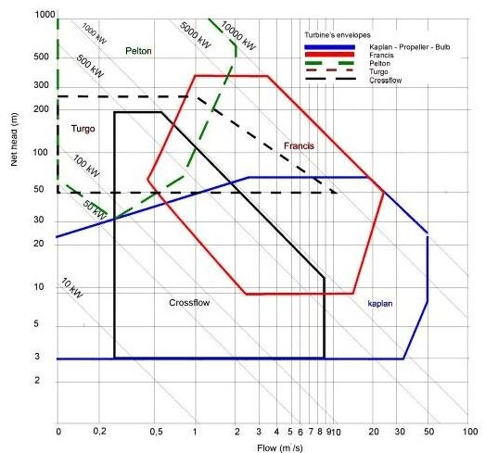

Figure 1 Selection of Turbine on the basis of head VS Flow rate [4]

### 1.2.1 Parts of a Turgo turbine

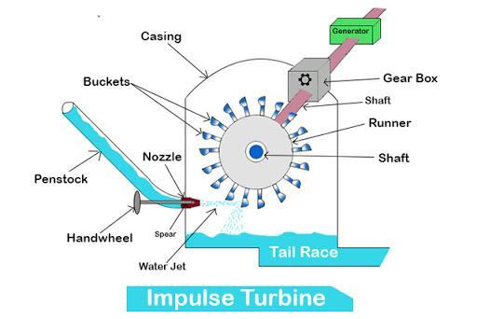

Figure 2 Turgo Turbine [3]

The following are the parts of a turgo turbine:

**I. Runner-** It is a solid circular disc with a cylindrical shaft in the center. The shaft and the runner both are made of high strength stainless steel where load on the turbine is considerably high. Runners are also made from cast iron where available water head is a bit low thus the force on the turbine is not high.

**II. Buckets-** Buckets are cup type hollow hemispherical structures bolted on the periphery of the runner. Jet strikes these buckets to rotate the runner. Their design plays a vital role in deciding the efficiency of the turbine. These are made either from stainless steel or cast iron.

**III. Nozzle and spear-** Nozzle directs the flow of water to the buckets with an increased velocity coming from a high speed. Spear is a conical structure which is moved in and out of a nozzle to regulate the flow of water striking these buckets.

**IV. Casing-** Casing of an impulse turbine is a preventive shielding over the turbine usually made of cast iron. It also prevents the water from splashing and guides it to the spillway.

### 1.2.2 Working principle of Turgo turbine

Water stored at a certain height is passed through a nozzle, situated almost at ground level or even below ground level that converts the energy of stored water into a high speed jet. The high speed water jet strikes the buckets attached to the runner, forcing the runner to rotate at its own axis converting the energy of the high speed jet into rotational energy. This rotational movement of the turbine shaft is used to produce electricity through the generator.

Spear is moved in and out of the nozzle to regulate the flow of water. To get maximum power output from a turbine the velocity of the jet striking the buckets should be twice the speed of rotating buckets. So velocity of a water jet is regulated according to the rpm or load of the turbine in such a way that we can keep the turbine running in its most efficient range.[5]

Power output capacity can be increased by increasing the number of nozzles used or closing a few nozzles when the load on the turbine is low.

When the load on the turbine decreases suddenly, and the spear could not act as fast enough to regulate the flow of the water jet, the rpm of the turbine will keep on increasing and could damage the turbine. To prevent this we use a deflector which deflects the flow of water jet away from the turbine buckets thus keeping the turbine under safe limits.[2]

## 1.3 Objectives

1. To prepare an AutoCAD model of an impulse Turgo turbine and prepare a manufacturing plan for fabrication of the project.

## 1.4 Scope of work

1. The project is done virtually by autocad and couldn't be fabricated.

# CHAPTER 2: METHODOLOGY

## 2.1 Study Design

The model was designed using the locally available resources working in a team. Following strategic approaches were followed to achieve our goal.

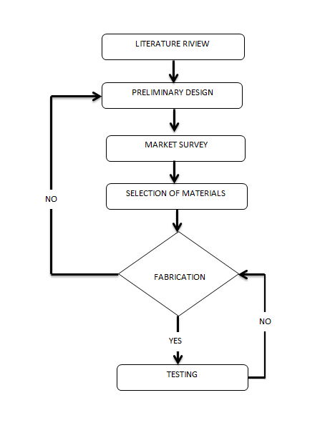

## 2.2 Literature Review

### 2.2.1 Early research and development

In 1919 Eric Crewdson, Managing Director of Gilbert Gilkes and Gordon Ltd realized that there could be a scope for a higher specific speed version of a Pelton runner. So he came up with the first turgo turbine. The motivation behind the turgo design was to combine the relatively high capacity and efficiency of Girard turbine and Pelton turbine. In 1920 Turgo turbine was tested independently by Dr. A.H Gibson showing a maximum efficiency of 83.5% under a head of 200 feet.

Further research was carried out on the design of the turgo turbine in 1936 by Gilkes’ Chief Engineer Ernest Jackson who was able to improve the efficiency of the turbine. In 1960 he made further improvement by making a wooden runner filled with paraffin wax that increased the efficiency greatly.

A one dimensional theory was developed in 1971 to show how the difference in relative energy between the inlet and outlet of an impulse turbine runner is proportional to jet/wheel diameter ratio and is more pronounced at relatively high specific speed whre the fall in efficiency due to mixing is greater. In 1972 research was carried out looking at the flow patterns relating to jet type turbines using both graphical and experimental techniques. The paper looked at the jet cross sections cut out by Pelton and Turgo turbines and how they interact with various runners.

### 2.2.2 Recent research and development

Turgo turbines found today operate in two main ranges, micro and small-medium range. Micro range from 100-200 W up to about 100-300 KW. They are used in remote areas for running small settlements and factories as they are cheap and easy to maintain.

Some recent researches carried out on this subject are as follows:

* Cobb and Sharp’s study looking at the impact of variation speed in speed ratio and jet alignment on Turgo turbine efficiency.
* Comprehensive experimental and analytical study carried out by Williamson who looked at the performance characteristics of a small scale turgo turbine used for medium heads.
* Research has been carried out by Khurana and Goyal looking at the impact of slit parameters on the erosion rate of Turgo turbines.

### 2.2.3 Open issues for further research and development

* A study of the optimum number of blades may be beneficial since reducing the number would reduce previous losses and increase flow path width and also may allow for better design of the outlet section and the trailing angle of the blades. However, this will delay the evacuation of the blades and may cause higher hydraulic losses.
* Improvement of the casing design.
* Some research maybe targeted to customize turgo turbines for specific applications like a multi-point design optimization of runners operating at a variable head, or the development of highly efficient simple design, low cost runners that are being used for micro and pico power production in developing countries and remote isolated regions.

## 2.3 Calculation

Mechanical Input

$Input power in kilowatts =Q×g×h×d$

Where,

Q= flow rate (cubic meter/second)

g= acceleration due to gravity

h= head in meter

d= Density of water

$Input power=Q×g×h×d$

Expected efficiency=70%

$Expected output power=input power× efficiency$

## 2.4 Market Survey

In the market survey various stores around Kathmandu and Banepa were explored in order to find the required materials for the fabrication of the Turgo turbine such as bearing, metal strips, metallic plate,dynamo etc. The main goal of surveying is for the material selection of the project and to be sure for the lowest minimal selection for the cost during fabricating the project.

## 2.5 Modeling

The whole Project was designed virtually in the software called AutoCAD. The diagram below represents the actual measurement of the model of the turbine.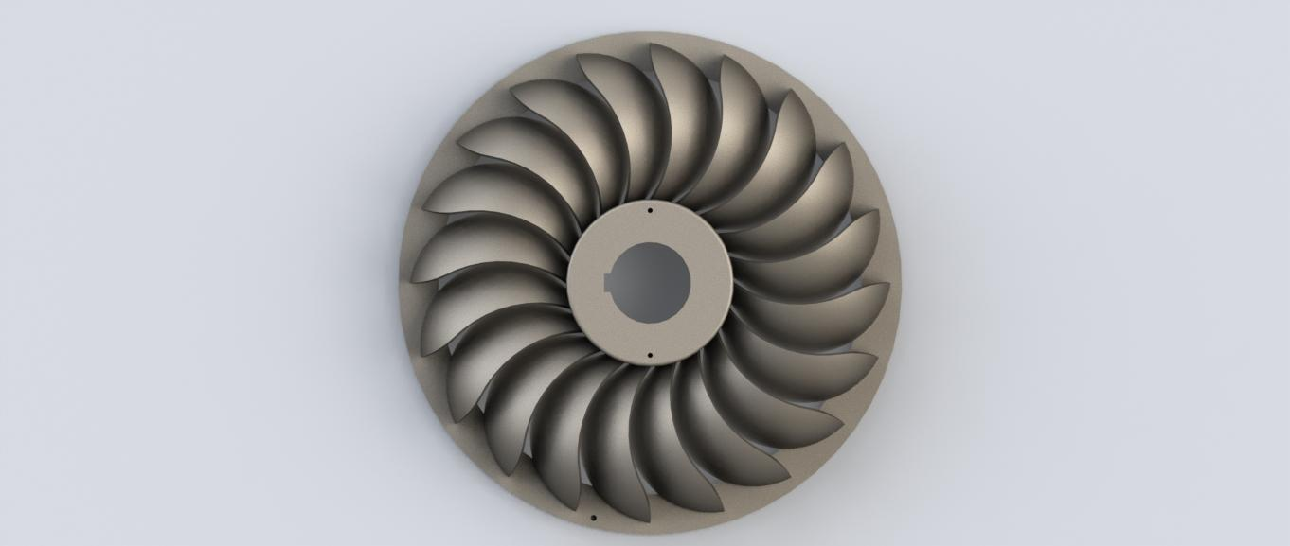

Figure 3 Top View of designed Turgo Turbine

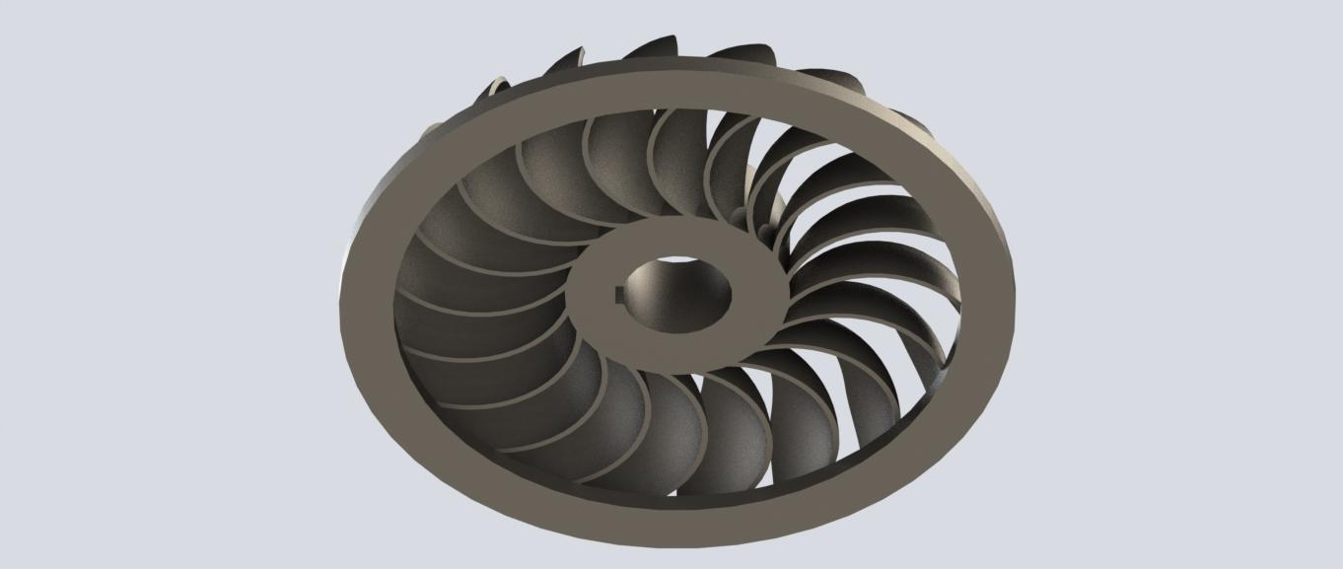

Figure 4 Bottom View of designed Turgo Turbine

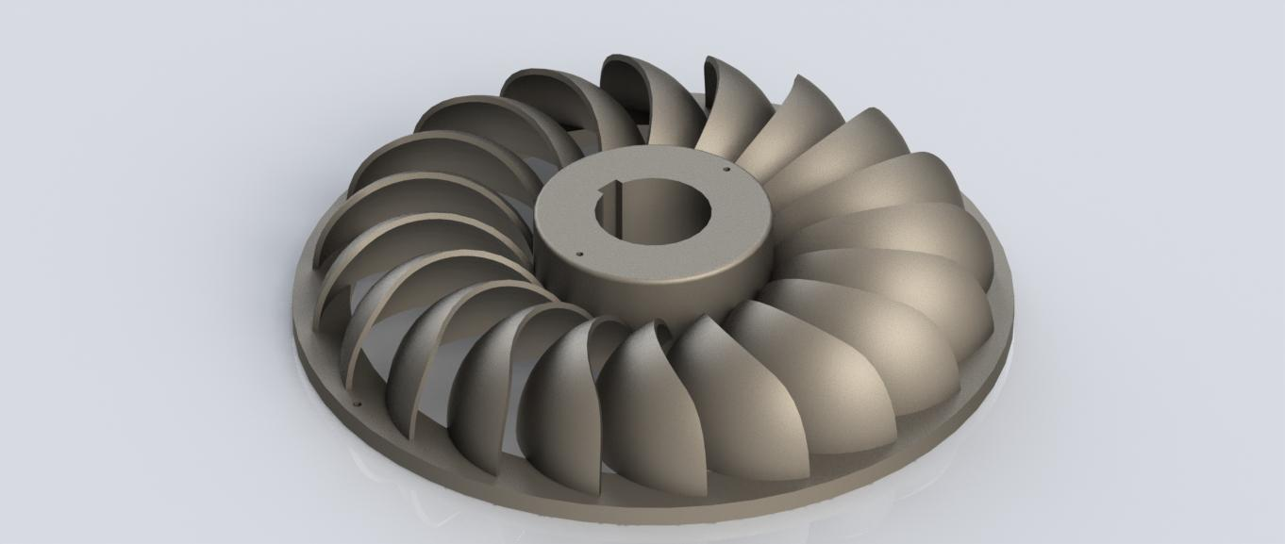

Figure 5 Angular View of designed Turgo Turbine

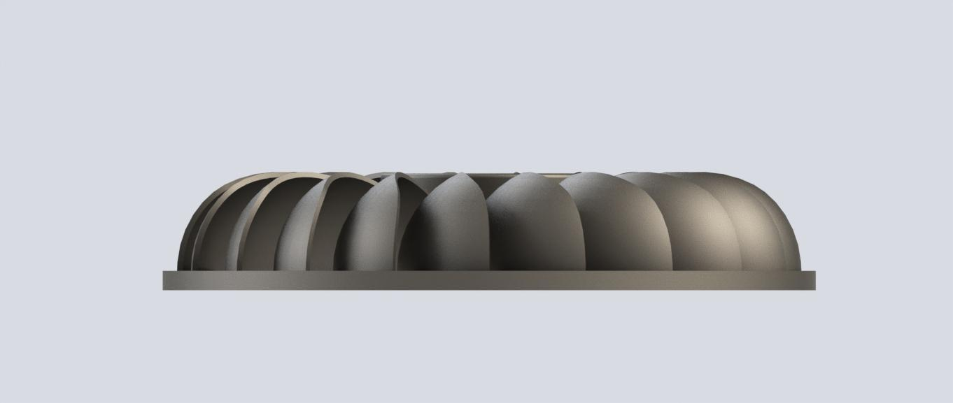

Figure 6 Side View of designed Turgo Turbine

## 2.6 Manufacturing Plan

* Shaft Rod: An iron rod can be cut into the required length of 34 cm for the shaft rod. The diameter of the rod was reduced to 15mm from 20mm using the lathe and grinding machine.
* Circular disc: An iron sheet can be cut into two circular discs using a hand cutter and its edges rounded off using a file.
* Runner Blades: For this we need an iron pipe and we cut it symmetrically into required pieces and each piece can be cut along the diameter to make the blades.
* Bearing Hub: An iron sheet is needed and be cut into two small rectangular pieces and bent to make the bearing hub and welded onto the frame.
* Framework: For supporting our turbine we need four rectangular iron rods of 30 cm each and can attach by welding the rods together for the rectangular frame and four circular rods are needed for welding in the frame for the stands.
* Lastly a dynamo is to be attached to the shaft by coupling in order to generate electricity.

## 2.7 Problems Encountered / limitations

As we didn't learn solid works or designing in this year properly we found it hard to model our project.

Since the design couldn't be fabricated due to the pandemic, so we couldn't encounter the problems during fabrication

# GANTT CHART

The chart below shows the entire working schedule for the team in a year 2021/22.

Table 1 GANTT CHART

|  |  |  |  |  |  |  |  |  |  |  |
| --- | --- | --- | --- | --- | --- | --- | --- | --- | --- | --- |
| **MONTH**  **Work Schedule** | **March** | **April** | **May** | **June** | **July** | **August** | **September** | **December** | **January** | **February** |
| **Group**  **formation** |  |  |  |  |  |  |  |  |  |  |
| **Literature**  **Review** |  |  |  |  |  |  |  |  |  |  |
| **Proposal**  **Defense** |  |  |  |  |  |  |  |  |  |  |
| **Research and analysis of the past papers** |  |  |  |  |  |  |  |  |  |  |
| **Market study** |  |  |  |  |  |  |  |  |  |  |
| **Conceptual**  **Design** |  |  |  |  |  |  |  |  |  |  |
| **Final**  **Design** |  |  |  |  |  |  |  |  |  |  |
| **Fabrication of the model** |  |  |  |  |  |  |  |  |  |  |
| **Testing of the model** |  |  |  |  |  |  |  |  |  |  |

# BUDGET EXPENSES

The following table shows the list of required materials need to be used and their respective prices

Table 2 BUDGET EXPENSES

|  |  |  |  |  |
| --- | --- | --- | --- | --- |
| S.N. | Parts | Rate(R.s.) | Quantity | Total Amount(R.s.) |
| 1) | Metal sheet | Provided by TTC | 1 | - |
| 2) | Iron pipe | Provided by TTC | 1 | - |
| 3) | Shaft rod | 80 per kg | 1 | 80 |
| 4) | Ball Bearing (6203 RS) | 75 per piece | 2 | 150 |
| 5) | Wooden block | Provided by TTC | 1 | - |
| 6) | Runner rim | Provided by TTC | 1 | - |
| 7) | Miscellaneous |  |  | 300 |
| 8) | Dynamo | 1000 for 12 volt | 1 | 1000 |
|  | Total |  |  | 1530 |

# 

# OUTCOME

At the end of the project a simplified Turgo turbine has been fabricated on the basis of the measurements provided. It consists of 20 runner blades in the turbine.

**Challenges**

The following challenges were faced which have caused deviations and delay in the fabrication process

* Due to lack of knowledge on the AutoCad software the fabrication was hard
* Finding the 3D Printing place was very hard.

# CONCLUSION

Therefore the project “**Fabrication of a simplified impulse turbine**” was successfully completed after the Modeling of the Turbine in Virtual Platform

At the end of the project we were able to understand the basic working of the Turgo turbine along with the working parts of it. We were also able to acquire the knowledge about using the various equipment and machineries involved in the fabrication process.

# REFERENCE

|  |  |
| --- | --- |
| [1] | D. Darling, "david darling," april 2012. [Online]. Available: http://www.daviddarling.info/encyclopedia/T/AE_Turgo_turbine.html. |
| [2] | Turbines Info, "turbines info," 22 May 2016. [Online]. Available: https://www.turbinesinfo.com/turgo-turbines/. |
| [3] | R. Rashid, “Impulse Turbine - Components, Working, Advantages, and DisadvantagesRAsis,” *Mechanical Walkins*, 12-Mar-2021. [Online]. Available: http://www.mechanicalwalkins.com/impulse-turbine-components-working-advantages-and-disadvantages/. [Accessed: Oct-2021]. |
| [4] | S. Sangal, A. Garg, and D. Kumar, *Review of Optimal Selection of Turbines for Hydroelectric Projects*, Apr-2012. [Online]. Available: https://www.researchgate.net/publication/292726939_Review_of_Optimal_Selection_of_Turbines_for_Hydroelectric_Projects. [Accessed: Oct-2020]. |
| [5] | Turbinesinfo, “Turgo Turbines,” *Turbines Info*, 12-Aug-2020. [Online]. Available: https://www.turbinesinfo.com/turgo-turbines/. [Accessed: Nov-2021]. |
| [6] |  |